Banking Loan Eligibility Using Production Rules, Propositional Logic, First-Order Logic and Prolog

1.Introduction
Loan eligibility is a decision-making problem in which a bank evaluates customer information such as income, credit score, employment status, existing loans, and repayment history. Artificial Intelligence techniques can represent this decision-making process using knowledge representation and reasoning methods.This study models the same banking loan eligibility problem using four approaches: Production Rules, Propositional Logic, First-Order Logic, and Prolog. The approaches are implemented using common customer data and common eligibility criteria. Their reasoning capabilities, expressiveness, and suitability for the problem are then compared.
2.Problem Statement
A bank wants to determine loan eligibility using income, credit score, employment status, existing loans, and repayment history. Model the decision-making process using production rules, propositional logic, first-order logic, and Prolog, and compare the reasoning capabilities of each approach.
Input
- Income
- Credit Score
- Employment Status
- Existing Loans
- Repayment History
3.Objectives
- To identify the factors involved in banking loan eligibility.
- To represent loan eligibility using production rules.
- To represent the same decision using propositional logic and first-order logic.
- To implement the logical rules using Prolog.
- To compare the reasoning capabilities, expressiveness, and limitations of the four approaches.
4.Input Parameters and Dataset
4.1 Input Parameters
Parameter | Description
Income | Monthly/annual customer income
Credit Score | Customer's creditworthiness score
Employment Status | Whether the customer is employed
Existing Loans | Number of existing loans
Repayment History | Previous repayment behavior

4.2 Customer Dataset
Customer | Income | Credit Score | Employment | Existing Loans | Repayment | Expected Result
Ravi | ₹60,000 | 750 | Employed | 1 | Good | Eligible
Priya | ₹30,000 | 650 | Employed | 2 | Good | Not Eligible
Rahul | ₹25,000 | 580 | Unemployed | 3 | Poor | Not Eligible
Anitha | ₹50,000 | 720 | Employed | 0 | Good | Eligible
Suresh | ₹50,000 | 750 | Employed | 1 | Average | Eligible

5. Decision Rules
Rule 1:
IF Income ≥ ₹40,000
AND Credit Score ≥ 700
AND Employment = Employed
AND Existing Loans ≤ 2
AND Repayment History = Good
THEN Loan Eligible
Rule 2:
IF Income ≥ ₹50,000
AND Credit Score ≥ 750
AND Employment = Employed
AND Existing Loans ≤ 2
AND Repayment History = Average
THEN Loan Eligible

6.Model 1 — Production Rules
Production rules represent knowledge using IF–THEN statements. The conditions are evaluated against customer information, and the corresponding conclusion is generated when a rule is satisfied.
6.1 Rules
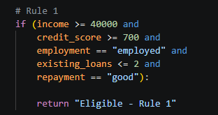

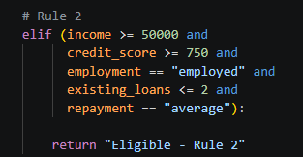

6.2 Execution
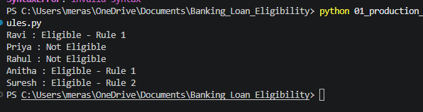
The Production Rules model successfully classified the five customers according to the predefined eligibility rules.

7. Model 2 — Propositional Logic
Propositional Logic represents statements as propositions that have either a True or False value. Logical operators such as AND (∧), OR (∨), NOT (¬), and implication (→) are used to construct decision rules.
7.1 Define Propositions
Symbol | Meaning
I | Income ≥ ₹40,000
C | Credit Score ≥ 700
E | Employment = Employed
L | Existing Loans ≤ 2
R | Repayment = Good
EL | Loan Eligible

I ∧ C ∧ E ∧ L ∧ R → EL
This means that if all five conditions are true, the customer is considered eligible.

7.2 Implementation
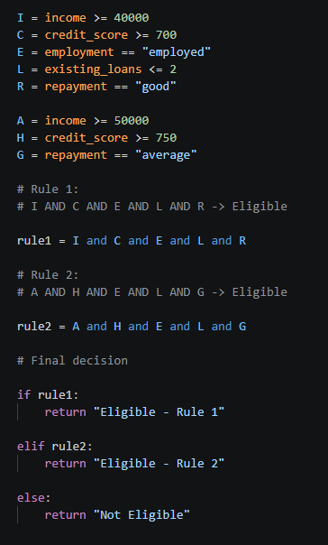

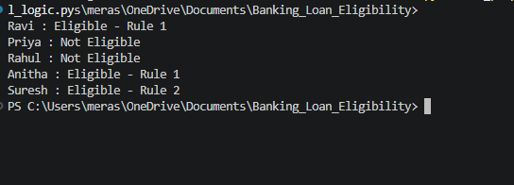
7.3 Output

The Propositional Logic implementation successfully evaluated the Boolean conditions and produced the expected loan eligibility decisions.

8. Model 3 — First-Order Logic
First-Order Logic extends propositional logic by introducing predicates, variables, constants, and quantifiers. It can represent individual entities and their properties.
8.1 Predicates
income(ravi, 60000)
credit_score(ravi, 750)
employment(ravi, employed)
existing_loans(ravi, 1)
repayment(ravi, good)
Here,
ravi = individual/customer
income = predicate
60000 = value
The universal quantifier ∀X means that the rule applies to every customer X satisfying the specified conditions.
8.2 Implementation

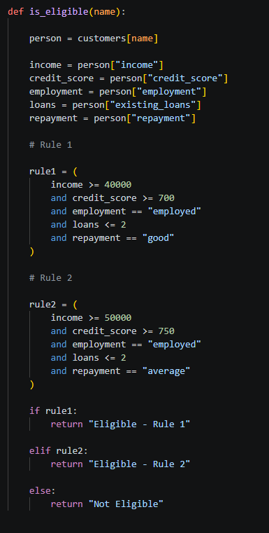

8.3 Output
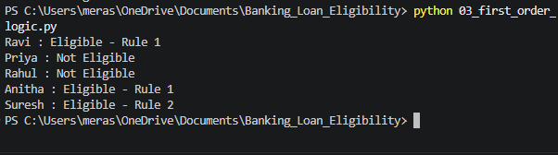
The First-Order Logic representation successfully modeled customers as individual entities with associated properties and applied general eligibility rules to determine their loan status.

9. Model 4 – Prolog
Prolog is a logic programming language that represents knowledge using facts and rules. It automatically performs logical inference when a user submits a query.
9.1 Facts
customer(ravi, 60000, 750, employed, 1, good).
Here,
ravi → Customer
60000 → Income
750 → Credit Score
employed → Employment
1 → Existing Loans
good → Repayment History
9.2 Rules
loan_eligible(Name) :-
customer(Name, Income, CreditScore, Employment, Loans, Repayment),
Income >= 40000,
CreditScore >= 700,
Employment = employed,
Loans =< 2,
Repayment = good.
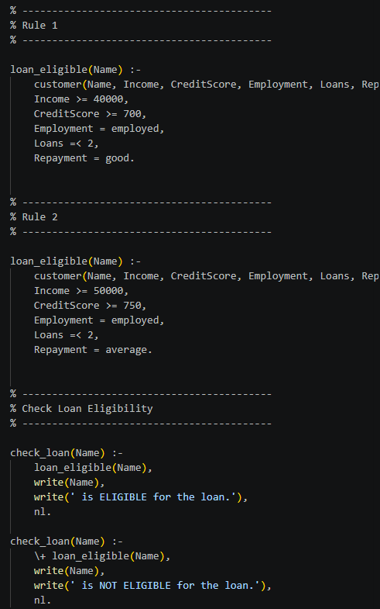
9.3 Implementation

9.4 Prolog Execution
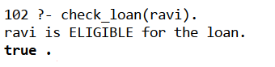

9.5 Query All Eligible Customers
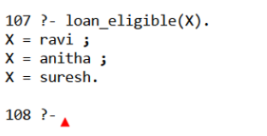

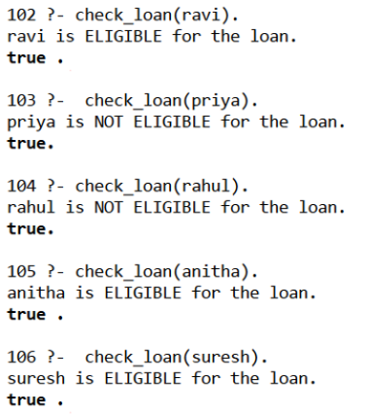

10.Comparison of Reasoning Capabilities
Feature | Production Rules | Propositional Logic | First-Order Logic | Prolog
Representation | IF–THEN rules | Boolean propositions | Predicates and quantifiers | Facts and rules
Variables | Limited | No | Yes | Yes
Quantifiers | No | No | Yes | Implicit
Individual entities | Moderate | Limited | High | High
Relationships | Limited | Very limited | Strong | Strong
Inference | Rule matching | Boolean inference | Deductive reasoning | Automated inference
Query capability | Moderate | Low | High | Very high
Backtracking | No | No | Not inherent | Yes
Expressiveness | Moderate | Low | Very high | High
Ease of understanding | High | High | Moderate | Moderate
Automation | Moderate | Low | Moderate | High
Suitability for this problem | High | Moderate | Very high | Very high

11. Detailed Reasoning Analysis
Production Rules
Production Rules are highly interpretable because the decision is explicitly represented using IF–THEN statements. They are suitable when the decision criteria are clearly defined.
Propositional Logic
Propositional Logic provides a simple mathematical representation of the decision using Boolean propositions. However, it does not naturally represent individual customers, variables, or relationships.
First-Order Logic
First-Order Logic provides greater expressive power because it supports variables, predicates, constants, and quantifiers. It can represent general rules that apply to multiple customers.
Prolog
Prolog provides executable logical reasoning. It supports variables, pattern matching, backtracking, and queries. Therefore, it is particularly suitable for implementing a rule-based expert system where users need to ask different questions about the knowledge base.

12. Same Customer — Four Reasoning Approaches
Production Rules
IF all conditions are satisfied
THEN Ravi is eligible.
Propositional Logic
I ∧ C ∧ E ∧ L ∧ R → EL
For Ravi:
True ∧ True ∧ True ∧ True ∧ True
→ True
First-Order Logic
income(ravi, 60000)
credit_score(ravi, 750)
employment(ravi, employed)
existing_loans(ravi, 1)
repayment(ravi, good)
The general rule applies to Ravi.
Prolog
?- loan_eligible(ravi).
Output:
true.
Although all four approaches produce the same final decision, their reasoning mechanisms differ. Production Rules use rule matching, Propositional Logic uses Boolean inference, First-Order Logic uses predicate-based deduction, and Prolog performs automated logical inference through queries and backtracking.

13. Results and Discussion
Customer | Expected | Production Rules | Propositional Logic | FOL | Prolog
Ravi | Eligible | Eligible | Eligible | Eligible | Eligible
Priya | Not Eligible | Not Eligible | Not Eligible | Not Eligible | Not Eligible
Rahul | Not Eligible | Not Eligible | Not Eligible | Not Eligible | Not Eligible
Anitha | Eligible | Eligible | Eligible | Eligible | Eligible
Suresh | Eligible | Eligible | Eligible | Eligible | Eligible

All four approaches produced consistent loan eligibility decisions for the five test customers. Ravi and Anitha satisfied Rule 1, while Suresh satisfied Rule 2. Priya and Rahul did not satisfy either eligibility rule. The consistency of the results demonstrates that the same decision-making problem can be represented using different knowledge representation and reasoning techniques.

14. Advantages and Limitations
Approach | Advantages | Limitations
Production Rules | Simple, interpretable, easy to modify | Can become difficult to manage with many rules
Propositional Logic | Simple and mathematically precise | Cannot naturally represent variables and entities
First-Order Logic | Highly expressive, supports relationships | More complex
Prolog | Automated inference, queries, backtracking | Mainly suited for symbolic reasoning

15.conclusion
The Banking Loan Eligibility problem was successfully modeled using Production Rules, Propositional Logic, First-Order Logic, and Prolog. The same customer data and eligibility criteria were applied to all four approaches. All approaches produced consistent eligibility decisions. Production Rules provided a simple and interpretable decision mechanism, while Propositional Logic represented the conditions using Boolean expressions. First-Order Logic provided greater expressiveness through predicates, variables, and quantifiers. Prolog provided executable logical reasoning through facts, rules, queries, and backtracking. The comparison demonstrates that the choice of reasoning approach depends on the complexity, expressiveness, and automation requirements of the decision-making problem.

16.References
- Russell, S. J., & Norvig, P. (2021). Artificial Intelligence: A Modern Approach (4th ed.). Pearson.
- Bratko, I. (2012). Prolog Programming for Artificial Intelligence (4th ed.). Pearson.
- Nilsson, N. J. (1998). Artificial Intelligence: A New Synthesis. Morgan Kaufmann.
- Giarratano, J. C., & Riley, G. D. (2005). Expert Systems: Principles and Programming (4th ed.). Thomson Course Technology.
- SWI-Prolog. SWI-Prolog Reference Manual. Available from SWI-Prolog Official Documentation

17. Github Repository
https://github.com/Tejaswinip007/MLA0103/tree/main/MLA0103%20COs/CO5%20AT3
